**Detailed instructions**

In this project, we will use Navicat for MySQL and MyEclipse Enterprise Workbench 6.0.

Step1:

Firstly, downloading the zip file that we uploaded on github and unzip it. And then find a folder called database and find the .sql called jspmcs5200sjkglxtldxb2y3mysql(something like that~) and execute it on Navicat like this(using localhost 3306):

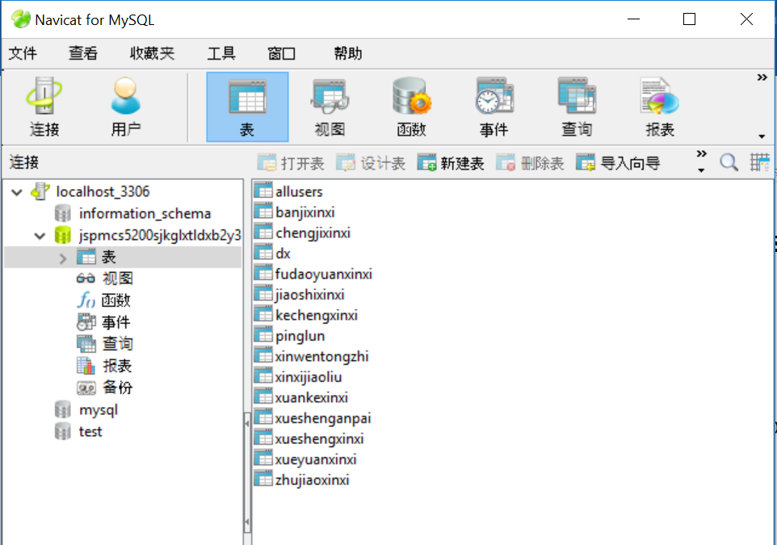

Step 2:

Then, use MyEclipse to execute .java and .jsp file. Find a folder called jspmCS5200(something like that~).

File - Import - General - Existing Projects into Workspace – Next – browse – choose this specific file.

When finish, deploy it and choose MyEclipse Tomcat. Then select 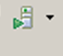and choose MyEclipse Tomcat.

Finally, run as - MyEclipse Server Application and you can get the result page.